Midway Roundtable Members:

In your February newsletter, my new best friend and colleague Tom Rychlik was kind enough to mention my name as author of a recently completed screenplay focused primarily on John Waldron but also Gene Lindsey and L.E.M. “Lem” Massey. In keeping with his good manners, Tom was too humble in giving me sole credit for authoring the screenplay (more below).

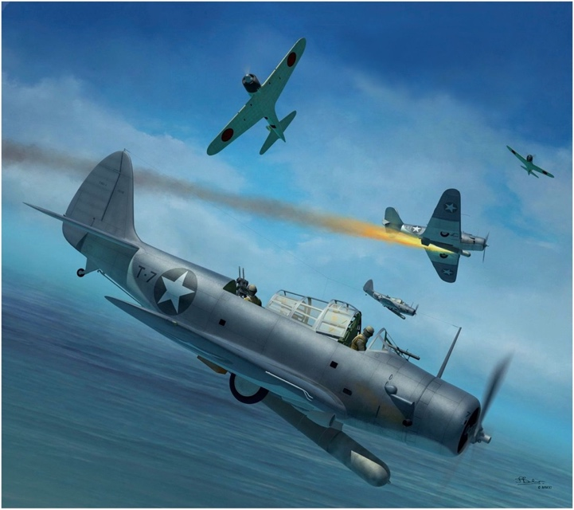

**Screenplay**

**“Johnny One”**

**Charles A. Race September, 2023 Thomas Rychlik, Major USMC (ret.) WGA# 2243312**

Tom’s inspiration for seeking the Medal of Honor for Waldron, Lindsey and Massey was Lord’s “Incredible Victory”. My inspiration was Victor Davis Hanson’s “Carnage and Culture” specifically the Midway chapter containing the passage “Annihilation of the Devastators”. Its focus on Waldron’s exploits, initiative and sacrifice moved me to tears. So motivated, I then began the screenplay with the working title of “Johnny One”, focusing on Waldron’s early life, career and courageous attack on June 4, intending it to be a dramatic action film for the big screen. Written based mostly on secondary sources, a few primary sources, personal interviews with Waldron grandson Tom LeDew in Pensacola, and most importantly, my dog-leafed, extensively-highlighted copy of “No Right to Win”. After many fruitless attempts to market “Johnny One” to screenplay agents, I paused my efforts. Then in Spring of last year, in a happy case of serendipity, LeDew mentioned his discussions with Tom Rychlik, and with our first conversation, we became fast friends and crusaders in our cause to give these martyred commanders their due. Tom made so many important and constructive revisions to “Johnny One,” that I now credit him as co-author of the screenplay. We like the screenplay, but the rubber starts to meet the road in April when it competes in a national screenplay competition, with feedback to be provided from producers and agents. Color us ‘excited but nervous’.

Mention was made by Tom R. of the Avalon Hill game “Midway” first produced in 1962. As it turns out, we avidly played this game during our formative years. Fun double-blind game, easy to play. But in the last 60 years, the board war game market (not including the video market)-- like histories of Midway-- has exploded with numerous games on the campaign and battle. Curious to how many, I checked the game site “Board Game Geek” and found to my amazement that there are 17 games on Midway! I venture to say, having played these games for 60 years, that it is the most gamed subject in board game history (not counting Yamamoto’s rigged game on the eve of the campaign!). Go to [www.boardgamegeek.com](http://www.boardgamegeek.com) and search “Midway” for titles, descriptions, photos, ratings and player feedback.

Charles Race

(904) 347-7906.